



LAB MANUAL
DBMS

Disclaimer: The content is curated from online/offline resources and used for educational purpose only
DFS using Adjacency List in Python

Objective:
To understand and implement graph representation using adjacency lists and perform Depth-First Search (DFS) traversal using Python.

Problem Statement:
Write a Python program to:
- Represent a graph using an adjacency list
- Implement and execute Depth-First Search (DFS)
- Print the nodes in the order they are visited starting from a chosen node

Equipment Required:
- A computer with:
  - Python 3.x installed
  - Jupyter Notebook (Anaconda or via pip install)
- Any code editor (optional)
- Internet (for further references)

Prerequisites:
- Basic Python (functions, loops, sets, lists)
- Graph theory: nodes, edges, adjacency list
- DFS traversal concept

Procedure:
Step 1: Define the Graph Class
We use a dictionary to represent the graph with adjacency lists.
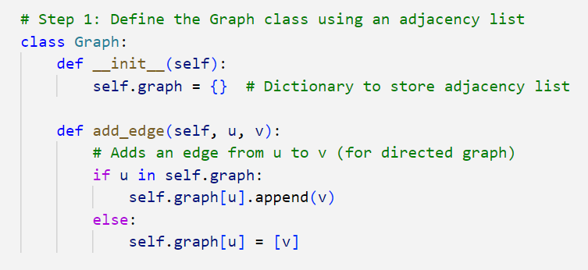

Step 2: Implement DFS Traversal Function
Use recursion and a set to track visited nodes.

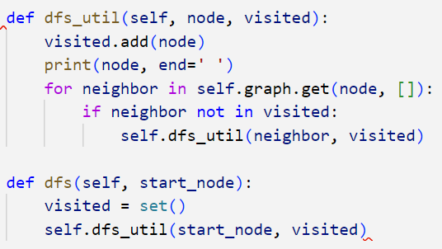

Step 3: Create a Graph and Add Edges
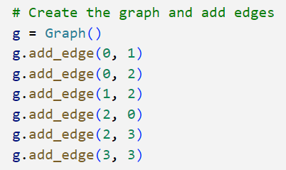

Step 4: Perform DFS Traversal

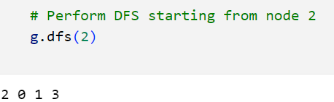

Conclusion
In this lab, we:
- Represented a graph using an adjacency list
- Implemented recursive DFS traversal
- Explored graph traversal in depth-first order

